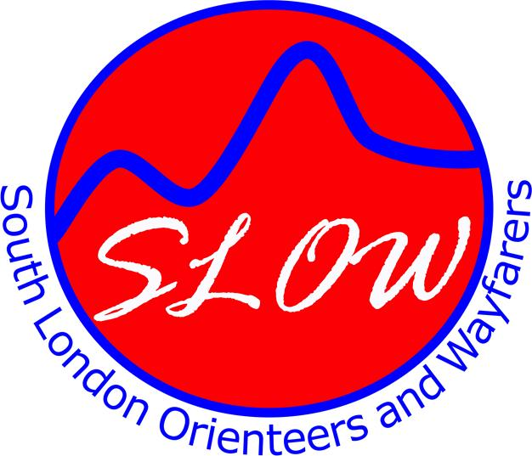
Sunday 1 July 2007

HAM RIVERSIDE

South London Orienteers present
Frolics Series 2007 - Race 2

Venue: Hawker Centre, Lower Ham Road, Kingston KT2 5BH. Grid Ref: TQ178712

Courses: White, Yellow, Light Green plus “optional extension” for those who want a longer run.

Registration: 9:30 am to 11:30 am Starts: 10:00 am to 12:00 am

Facilities: Café, bar, food, changing, showers, parking

Fees: £4.00 for seniors, £1.00 for juniors. Add £2 (50p junior) if not a member of SLOW or BOF. Add £1 (50p junior) if you need to hire an SI card (electronic timer). FREE entry for SLOW juniors and Kingston schools orienteering teams.

Directions: By public transport: No. 65 bus from Kingston or Richmond. Alight at Lower Ham Road.
By road: The Hawker Centre is situated by the River Thames, at the junction of Richmond Road (the main road between Kingston and Richmond) and Lower Ham Road.
Enquiries: Don McKerrow chair@sloweb.org.uk

SLOW website: (results and general info) www.sloweb.org.uk

FROLICS: Fun Running & Orienteering in London Inter-Club Series
A series of 5 summer events using the Light Green course; a handicap system adjusts your time according to age, sex and previous history of orienteering – being an experienced orienteer can be a disadvantage! The top 6 finishers on handicap count towards each club’s score.

