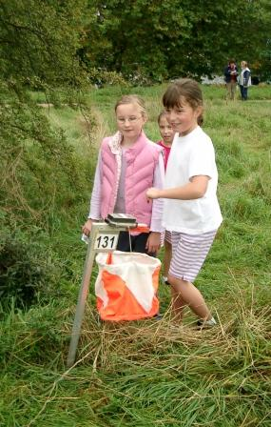**Orienteering**

**for children and families**

**organised by**

**South London Orienteers**

**Hawker Centre, Ham**

**(YMCA Kingston) between Kingston & Richmond**

**Saturdays in 2010**

**12 June 3 July**

**19 June 10 July**

**26 June**

**2.30-4.00pm**

* ideal fun way to learn and practice orienteering skills
* orienteering games and activities for all ages
* more challenging orienteering courses for older children and adults
* café, toilets, changing available
* no charge!
* dogs welcome under control
* run by British Orienteering licensed coaches

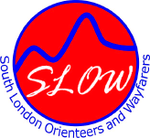Location map: <http://bit.ly/aWg2vh>

For further information, please contact

Development Officer, Christine Robinson,

on 020 8255 7176 or [development@sloweb.org.uk](mailto:development@sloweb.org.uk)

**www.sloweb.org.uk**