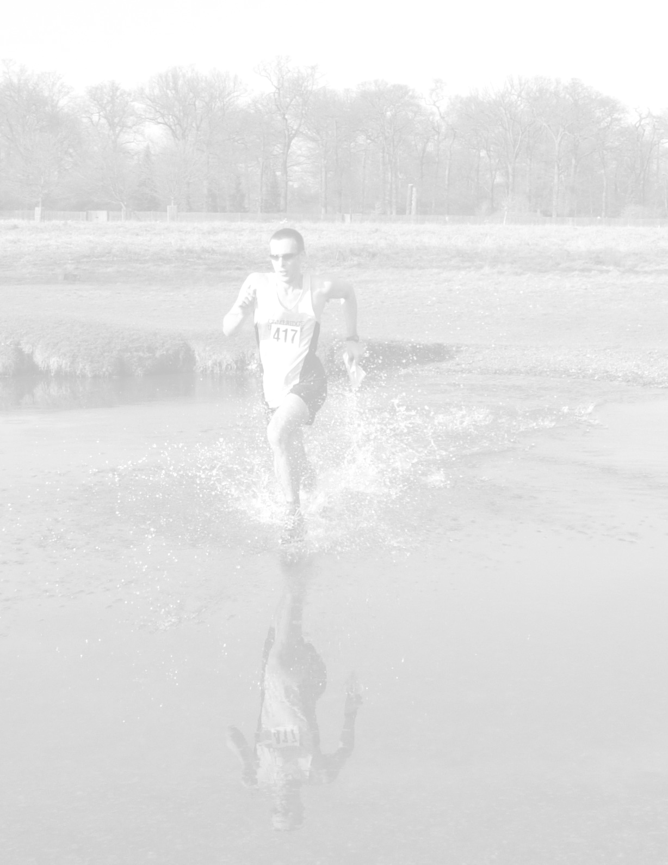  South London Orienteers  Trail Challenge  Summer Evening Series  10km and 6km Races  Day 1: Tuesday 11th May 2010 – Bushy Park  Start from Hampton Wick Royal Cricket Club Cricket Club, SE corner of Bushy Park, Park Rd, Hampton Wick, Kingston upon Thames, KT1 4AZ  Day 2: Tuesday 22nd June 2010 – Ham Riverside  Start from Hawker Centre, Lower Ham Road, Kingston upon Thames, KT2 5BH  Day 3: Tuesday 10th August 2010 – Richmond Park  Start from Ranelagh Harriers clubhouse, Petersham Road, TW10 7AA  A TRAIL CHALLENGE is a mass start cross-country race over tracks and trails with a difference. The course is not marked out by marshals but is instead defined by checkpoints that are marked on a professionally made colour map. The TRAIL CHALLENGE arises from choosing the fastest route between them.  Starts  10km race at 7:30pm, 6km race at 7:40pm  INFORMATION AND ONLINE ENTRIES: www.sloweb.org.uk/trail/ |  | ENTRY INFORMATION: adults £4 in advance or £6 on the day for each day’s event; juniors and students half-price. All entries in advance via the online link in www.sloweb.org.uk/trail/ All three events on Day 1, Day 2 and Day 3 can be entered in advance for the discounted price of £10 (or £5 for juniors and students).  The entry fee includes detailed map of the area and hire of an electronic 'finger' timer to record your arrival at checkpoints. The electronic 'finger' timer will produce instant results at the finish showing your time between checkpoints.  The closing date for each race is the Friday prior to the race. Entries on the day accepted, subject to entry limit not being reached.  REGISTRATION: will be open from around 6:15pm. Please aim to be ready 10 minutes before your start. Your competition map with the marked checkpoints will be distributed during a race briefing ten minutes before each start.  PRIZES: Usual categories including women & veterans. In the 6km race only women, juniors and super-veterans are eligible for prizes. The more entries in advance we get, the more wine/beer/chocolates will be given away.  BAGS AND CHANGING FACILITIES: On all 3 days, there are changing facilities at the event location. The event location will be manned at all times such that bags may be left behind during the event. However please do not bring anything valuable!  FOOD: On all 3 days, it will be possible to buy food and drink after the event either at the event itself or at a pub next door.  ENQUIRIES TO: Dan Findlay-Robinson,  PHONE: 07971552785 EMAIL: trail@sloweb.org.uk  DIRECTIONS:  Please see the map of each event’s location on the web www.sloweb.org.uk/trail/  Competitors take part in this race at their own risk. As entries and results will be processed by computer, your entry will be taken as agreement to this.

